RpiScope:An Effective Tool For Farmers

Marc Mathew
Fr. Conceicao Rodrigues College of Engineering
Bandra,Mumbai
marc.mathew19@gmail.com
Rachel Joseph
Fr. Conceicao Rodrigues College of Engineering
Bandra,Mumbai
rjrachel18@gmail.com
Rubina Parveen
Fr. Conceicao Rodrigues College of Engineering
Bandra,Mumbai
rubina15parveen@gmail.com

Abstract—Agriculture plays a vital role in the Indian economy. The monetary losses due to biotic factors account to millions of dollars per annum. It is too tedious and cumbersome for the farmers to travel far and get the sample examined. This paper works on the digitization and automation of a compound microscope by using a Raspberry Pi kit and a Pi camera module. The captured data from the raspberry pi kit can undergo diagnosis instantly by the biologist/expert and the focus adjustment of the microscope can also be done remotely by the expert. The main concern of this paper is to bridge the gap between a farmer and a biologist by providing instant remedial solution to the farmer without further delay.
Keyword-semi-automated microscope, live-streaming, focus adjustment

Introduction
In India about 58% of the rural households still depend on agriculture as their principal means of livelihood. The total farm yield losses in India due to biotic factors ranges between 10 to 30%. The crop losses must be curtailed by adapting a suitable crop protection or enhancement method. The overall crop yield can be easily improved by timely detection of the pathogens affecting the plant and taking obligatory actions However, since majority of the farmers in India are uneducated and due to primitive methods of agriculture still being used the detection of pathogens by farmers is not an easy task.
Plant pathologists study the growth of various bacteria using a microscope. Since the traditional microscope does not provide a digital output the image cannot be sent or stored for further use. Digitization of a microscope would help reduce the inconvenience faced by pathologists as it will provide a better view of the microbes and save the important sample data for future use. [1] Video capturing of the microbes makes it possible to continuously monitor the living cells and send it to any other place in minutes. [2]
This project aims at designing a semi-automatic microscope for detection of pathogens affecting the commonly grown crops and provides remedial solutions after analysis. This setup can be installed in each village which consists of a microscope, raspberry pi, pi camera module, motors and driver circuit. The microscopic images are acquired using a raspberry pi camera module and then sent real time to a central monitoring location. This central monitoring location can be a small section of any agricultural institute of India. An expert (generally a pathologist of this institute) analyzes this image and sends a message back to the farmer explaining the solution for the plant infestation. An added feature is that the expert can control the focus of the microscope over the internet. The proposed methodology of the project is:
1. To integrate Raspberry Pi 3 and its camera module with the microscope.
2. To semi-automate the microscope using appropriate belt- motor mechanism.
3. To make a website which demonstrates the live-streaming of the bacteria acquired using a Raspberry Pi Camera. Also information of various diseases which are very common in Indian crops, control buttons to adjust the focus of the microscope and an option to provide a remedial solution.
4. To analyze agricultural samples under the microscope and determine the microbes present by an expert present at any corner of the world.
5. To send a remedial solution back to the farmer based on the evaluation results.

Implementation
This system uses a compound microscope which comes with different lens options of 10x, 15x for eyepiece and 10x, 45x and 100x for the objective lens. The microscope is digitized using a raspberry pi 3B module which performs the functions of a mini computer, camera which gives a picture quality of maximum 5MP, motors and driver circuits for focus adjustment.
  - Live Streaming
The camera module is placed at the microscope’s eyepiece which gives an enlarged image of the sample which is placed on the stage [2]. To obtain a clear image from the Raspberry Pi camera a special cap on which the raspberry pi camera can be mounted was developed. This acquired image is live streamed onto the website. The IP address provided to the raspberry pi by the router is local to the network and non-static due to which it cannot be accessed outside the local network. By using the concept of port forwarding and applying a static IP address to the raspberry pi it is possible to access it over the internet. [6] Port forwarding redirects the data to a specific port address (here port 80). The live streaming is done by making the raspberry pi as a web server which uses port 80 to stream the live video captured by the camera. The main purpose of setting up a web server is to store, process and deliver web-pages to clients as per their requirements. Here the raspberry pi is set up as the server and the expert is the client who accesses data from the server. Live streaming of the microscopic bacteria is first recorded and then converted into a webpage.

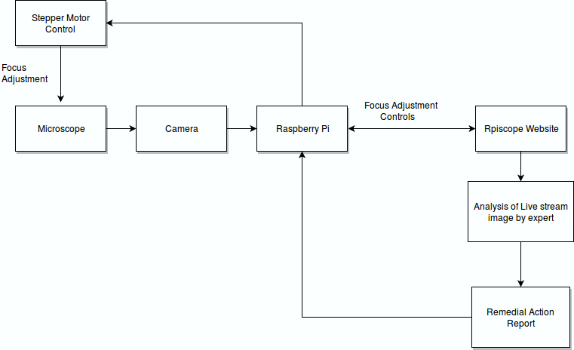
Fig 2.1: Block Diagram
This webpage is then accessible over the internet using port forwarding technique. This live streaming can be viewed by a microbiologist or an agricultural expert who will be able to easily analyse the sample and send a remedial solution back to the farmer.
This system will help the agricultural expert present at any corner of the world to remotely check the samples. The expert can then give a remedial solution within 5 minutes to farmers in villages where traditionally getting an expert advice would take minimum 2-3 days time.

Focus Adjustment
Adjustment of the focus is very important factor in obtaining a clear image of the sample. For proper image acquisition the focus of the microscope needs to be set accurately. This provision is given to the expert, who can use the buttons provided in the website to remotely control the focus adjustment of the microscope. A 12V, 2A Stepper motor is attached to the coarse adjustment knob of the microscope via a belt mechanism. Stepper motor is an electromagnetic device, which converts discrete electrical pulse signals into mechanical angular displacement [3]. A stepper motor has certain unique features over normal motors. This includes fine step size (minimum step size=1.8 degree for full-step sequence) and high holding torque. Due to other advantages such as low cost, ease of control and no accumulation of errors stepper motors are widely used in applications were precise control is required. It is being driven by a L298n motor driver as the raspberry pi GPIO pins provides an output voltage of maximum 5V only. The code for the stepper motor is written in python. The website has control buttons to move the coarse knob of the microscope up or down depending upon the requirement to obtain a clear image.
Identify applicable funding agency here. If none, delete this text box.
There are four buttons on the webpage RESET, UP, DOWN and STOP. On clicking the RESET button, the lens column of the microscope moves up to an extreme end. The UP button is provided to move the lens column up and the DOWN button to move it down. The STOP button is provided to stop the motor. By varying the step-size and delay, the coil energization of the stepper motors can be varied. This can be used to change the steps required for focal adjustment.

Website
A website is developed using html script which is hosted on the internet and can be accessed by the expert from anywhere. Every lab setup will have a login and password and also an E-mail ID of its own. The main page of the website consists of the live stream window where the expert can see the microscopic image of the sample. The page also consists of information of various diseases which are very common in wheat, rice and some information about the samples like the onion cells which was used in this project. The control buttons are also provided in this page for the expert to adjust the focus of the microscope. There are four buttons and every button which is clicked sends a value to the raspberry pi which is read by the pi and depending upon the value the required action is performed. A send button is also provided to the expert on the webpage which is used to send a remedial solution to the lab E-mail address. The remedial solution mainly includes the type of pesticide to be applied, the quantity and the period for which it should be applied.

Backlight unit
The bottom part of a traditional microscope consists of a concave mirror and a condenser unit. The light source adjustment is a cumbersome process as it varies a lot with the surrounding light. Hence, a special backlight unit is designed. The unit is composed of many white light emitting diodes (LED). This system behaves as an efficient light source and by proper adjustment of the condenser unit light is dispersed properly to obtain a clear image of the specimen. [1]

Result
The stepper motor and driver circuitry provide a minimum step angle of 1.8 degree when the full-step sequence is used. The step size angle and delay were set for this purpose . On varying the step-size and the delay the speed of focal length adjustment of microscope can be varied.
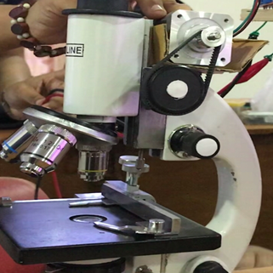
Fig 2:Focal Length adjustment using motors
The live streaming of the microbes onto a website over the internet is achieved. A free domain was purchased, and the website is hosted online making it accessible from anywhere in the world. Fig.2 represents the designed website. The right side of the website represents the live streamed image from the microscope.
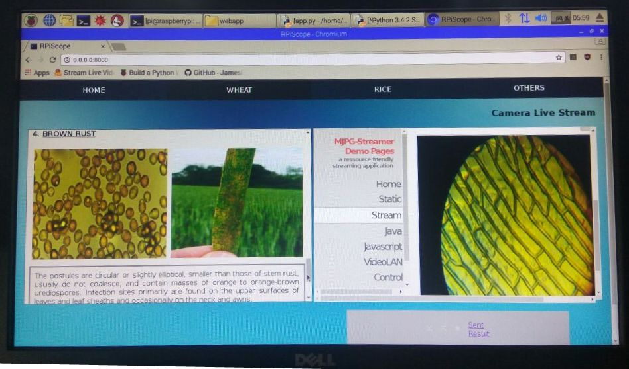
Fig 3: Website with live-streamed image

Conclusion
In summary, the use of RPiScope (Raspberry Pi integrated with a microscope) for timely determination of pathogens was demonstrated. The results from this proposed system show that the live streamed image can be easily used by the expert for analysis. The focus of the microscope can be precisely controlled with the help of motors enabling the expert to determine the cause of damage on the crop. The remedial solution provided to the farmer is instantaneous preventing further damage.

Future Scope
• A database can be added which maintains a record of all the samples which are analyzed.
• A special feature can be added which the live-stream is automatically redirected to another expert if an expert is currently unavailable.
• The horizontal and vertical adjustment of the microscope stage can be controlled with motors enabling to concentrate on certain areas of the slide.
• It can be used to study the trends of crop infestation in different parts of the country.
• It can be used for the diagnosis of certain human conditions or diseases.
• Auto-focusing feature needs to be added which reduces the work of the expert.[4]

Acknowledgment
The authors would like to acknowledge the support provided by the Department of Electronics, Fr. Conceicao Rodrigues College Of Engineering particularly, the continuous guidance provided by Prof. Swapnali Makdey and Prof. Ajay Koli.

References

- Yu-Jen Chen, Yu-Sing Yeh, Ming-Shing Young, YanChay Li, Chen-Song Chiang, Sun-Lon Jen, e-Nung Huang “The study of a handheld digital microscope for biomedical applications”IEEE,2008.
- Komalpreet Kaur,jaspal Singh “A Review for Digital Microscope Using Raspberry Pi” International Journal on Recent and Innovation Trends in Computing and Communication(IJRITCC) ,2017.
- Zhicong Chen “Control Technology of Stepper Motor Driver and its Design for Applications” May2008.
- I. Ming Yang, Li Luo, “A Rapid Auto-focus Method In Automatic Microscope”IEEE,2008.
- Practical Microscopy by L.C. Martin and B.K. Johnson.
- Data Communication and Networking by Behrouz Forouzan .

